PROJECT DOCUMENTATION
PreCare AI
An AI-Powered Multimodal Pregnancy Report Analysis
and Maternal Care Recommendation System
Gentle Care, AI Precision

Table of Contents
1. Title
2. Abstract
3. Software and Hardware Requirements
4. Existing System Overview
5. Proposed System Description
6. Scope of the Project
7. Benefits of the Proposed System
8. Feasibility Study
9. Detailed Module Descriptions
10. Architecture Diagram
11. Data Flow Diagram (DFD)
12. User Interface Design

1. Title
PreCare AI — An AI-Powered Multimodal Pregnancy Report Analysis and Maternal Care Recommendation System
PreCare AI is a secure, AI-driven pregnancy companion platform that automatically analyzes maternal medical reports, translates clinical findings into plain-language guidance, classifies maternal health risk, and connects expectant mothers with the nearest qualified gynecologists and maternity clinics.

2. Abstract
Expectant mothers routinely receive laboratory and diagnostic reports filled with clinical terminology that is difficult for a non-specialist to interpret without direct physician consultation. This gap between report generation and medical explanation can delay the recognition of risk factors during pregnancy, particularly in regions with limited access to obstetric specialists. PreCare AI addresses this gap by combining multimodal large language models with geolocation-aware healthcare discovery in a single, secure web application.
The system allows a patient to upload a pregnancy-related medical report in PDF, image, or Word format. The platform extracts the underlying text or visual content, forwards it through the NVIDIA NIM inference pipeline (using Meta Llama vision and text models with automatic fallback), and returns a structured, validated JSON output containing patient demographics, extracted biomarkers, a maternal risk classification (LOW, MEDIUM, or HIGH), a warm plain-language summary, and actionable recommendations. When a report is classified as MEDIUM or HIGH risk, the system automatically searches nearby maternity clinics using the Google Places and Geocoding APIs (with OpenStreetMap Nominatim as a fallback), ranks them using AI-based reasoning, and enables the patient to request a priority checkup.
All report data, analysis results, and locations are stored securely in a Supabase PostgreSQL database with row-level security, backed by a local file cache for resilience in read-only serverless environments. The result is a system that shortens the time between report generation and informed action, while remaining lightweight enough to run on standard consumer hardware and modern web browsers.

3. Software and Hardware Requirements

3.1 Software Requirements
Category | Technology / Tool | Purpose
Frontend Framework | React 19, Vite 6, TypeScript | Client-side UI and build tooling
Styling | TailwindCSS v4 | Utility-first responsive styling
UI Enhancements | Lucide Icons, Framer Motion | Icons and animation
Backend Runtime | Node.js (v18+), Express, tsx | Server-side application logic
Deployment | Vercel Serverless Functions | Production hosting and API routes
Database | Supabase (PostgreSQL) + Storage Buckets | Persistent data and file storage
AI / LLM Services | NVIDIA NIM API (Llama 3.2/3.3 Vision & Text), Google Gen AI SDK | Report analysis and summarization
Document Parsing | Mammoth.js | Word document text extraction
Mapping Services | Google Maps Places & Geocoding API, OpenStreetMap Nominatim | Clinic discovery and geolocation
Email Delivery | Resend API | Transactional security notifications
Version Control | Git and GitHub | Source control and collaboration
Operating System | Windows 10+, macOS 12+, or Linux (Ubuntu 20.04+) | Development environment

3.2 Hardware Requirements
Component | Minimum | Recommended
Processor | Dual-core 2.0 GHz | Quad-core 2.5 GHz or higher
RAM | 4 GB | 8 GB or higher
Storage | 5 GB free space | 10 GB SSD
Network | Stable broadband (for API calls to NVIDIA NIM, Google Maps, Supabase) | High-speed broadband / fibre
Client Device | Any device with a modern web browser (desktop, tablet, or mobile) | Same, with GPS for accurate geolocation
Because the AI inference and database operations run on managed cloud services (NVIDIA NIM, Supabase, Vercel), the application itself does not require dedicated on-premise server hardware — only a development machine meeting the specifications above and, for end users, any internet-connected device with a modern browser.

4. Existing System Overview
In the conventional workflow, an expectant mother undergoes laboratory testing or diagnostic imaging at a clinic or diagnostic lab. The results are typically issued as a printed or PDF report containing raw biomarker values, reference ranges, and clinical terminology intended for a trained physician rather than a lay reader. The existing process suffers from several limitations:
- Reports are written in clinical language that most patients cannot interpret without a follow-up doctor visit, which may be delayed by appointment availability.
- There is no automated mechanism to flag abnormal biomarkers or classify the urgency of the findings immediately after the report is issued.
- Patients, especially those in unfamiliar locations or new to a city, have no integrated way to discover nearby, appropriately rated gynecologists or maternity clinics based on their report's urgency.
- Report storage is fragmented — physical copies, email attachments, or hospital-specific portals — with no unified, patient-owned digital record.
- Existing generic health apps either provide only static, non-personalized pregnancy information or lack secure, structured handling of actual diagnostic report data.
These gaps can result in delayed recognition of risk factors such as anemia, gestational hypertension, or abnormal glucose levels — conditions where early, informed action materially improves maternal outcomes.

5. Proposed System Description
PreCare AI proposes an integrated, AI-driven platform that closes the gap between report generation and patient understanding. The system is designed around three pillars: automated interpretation, risk-aware triage, and connected care.
- Automated Interpretation: Uploaded reports (PDF, image, or Word) are processed through a multimodal AI pipeline that extracts biomarkers directly from text or scanned/photographed documents, removing the need for manual data entry.
- Risk-Aware Triage: Every analyzed report receives a structured LOW / MEDIUM / HIGH risk classification generated from validated AI output, giving patients and caregivers an immediate, consistent signal of urgency.
- Connected Care: Patients flagged as MEDIUM or HIGH risk are automatically shown nearby, AI-ranked maternity clinics and gynecologists with the option to request a priority appointment, shortening the time between diagnosis and care.
- Plain-Language Communication: Alongside the technical output, the system generates a warm, jargon-free summary so patients understand their own health status without needing to decode clinical terms unaided.
- Secure, Persistent Records: Every report, its extracted data, and its AI analysis are stored in a structured Supabase database, giving the patient a durable, retrievable health record with resilient local fallback caching.
Compared to the existing system, PreCare AI removes manual interpretation delays, standardizes risk assessment, and actively connects the patient to the next step of care rather than leaving that step to the patient's own initiative.

6. Scope of the Project

6.1 In Scope
- Ingestion and AI-based analysis of pregnancy-related medical reports in PDF, image (JPEG/PNG), and Word (.doc/.docx) formats.
- Automated extraction of patient demographics and biomarker values, with LOW / MEDIUM / HIGH maternal risk classification.
- Generation of a plain-language patient summary and actionable recommendations alongside the technical output.
- Geolocation-based discovery and AI-ranking of nearby gynecologists and maternity clinics, with a priority-booking request flow for MEDIUM/HIGH risk patients.
- Secure, patient-owned storage of reports, extracted data, and analysis history in a Supabase-backed database with row-level security.
- Account registration, sign-in, and transactional security-alert notifications.
- A responsive web client accessible from desktop, tablet, and mobile browsers.

6.2 Out of Scope (Current Version)
- The system does not replace a licensed physician's diagnosis — it is a triage and communication aid, not a diagnostic or prescriptive medical device.
- No integration with hospital EHR/EMR systems, insurance platforms, or wearable health-monitoring devices in the current version.
- No real-time video consultation or telemedicine functionality — the system facilitates discovery and booking requests only, not the consultation itself.
- Formal regulatory certification (HIPAA, GDPR, or equivalent regional medical-data standards) is architecturally supported but not yet completed.
- Multi-language report analysis and UI localization are not included in the initial release.

6.3 Future Scope
- Expanding language support for both report analysis and the patient-facing summary.
- Integrating telemedicine video consultations directly into the priority-booking flow.
- Adding wearable and home-monitoring device data (blood pressure, glucose) to enrich risk classification over time.
- Pursuing formal HIPAA/GDPR compliance certification for large-scale clinical deployment.
- Extending clinic coverage and ranking to additional regions and insurance-network partnerships.

7. Benefits of the Proposed System
Faster, clearer understanding: Patients receive a plain-language explanation of their report within minutes instead of waiting for the next available doctor's appointment to have results explained.
Earlier risk detection: Automatic LOW/MEDIUM/HIGH classification immediately flags concerning biomarkers, reducing the chance that a risk factor such as anemia or gestational hypertension goes unnoticed between visits.
Reduced anxiety: A warm, jargon-free summary helps patients process potentially worrying clinical information without the fear that comes from misreading raw lab values.
Faster path to care: MEDIUM/HIGH risk patients are immediately shown AI-ranked, nearby clinics with a priority-booking option, shortening the gap between diagnosis and treatment.
Improved access in underserved areas: Geolocation-based discovery helps patients who are new to a city or lack an existing obstetrician find appropriately rated care nearby.
Unified, durable health records: Reports, extracted data, and AI analysis are consolidated into one secure, patient-owned record instead of being scattered across physical copies, emails, and hospital portals.
Reduced manual workload: Automated extraction and structuring of biomarker data removes manual data entry, freeing clinical staff to focus on cases that genuinely require their judgment.
Resilient, low-cost operation: Reliance on managed cloud services and graceful fallbacks (OpenStreetMap when Google Maps is unavailable, local JSON cache in read-only environments) keeps the system inexpensive to run and resilient to individual service outages.
Security-conscious by design: Row-level security, service-role key separation, and transactional account-activity alerts give patients confidence that sensitive medical data is handled carefully.

8. Feasibility Study

8.1 Technical Feasibility
The system is built entirely on mature, well-documented technologies — React, Node.js/Express, TypeScript, and Supabase — supported by managed AI inference (NVIDIA NIM) and mapping APIs (Google Maps, OpenStreetMap). No custom AI model training is required; the system relies on API-based inference with schema-validated JSON output, which is technically achievable with standard prompt engineering and fallback logic. The use of Vercel serverless functions removes the need for dedicated server infrastructure, and the local JSON fallback cache mitigates risks from read-only or transient serverless environments. Overall, the architecture is technically sound and implementable with a small development team.

8.2 Economic Feasibility
Development costs are primarily limited to third-party API usage (NVIDIA NIM inference, Google Maps API calls, Resend email delivery) and Supabase hosting, all of which offer free or low-cost tiers suitable for a pilot deployment. Because the frontend and backend are consolidated into a single Node.js/Vite project deployable on Vercel's free or hobby tier, initial hosting costs are minimal. The graceful degradation to OpenStreetMap when a Google Maps key is not configured further reduces mandatory recurring costs, making the system economically viable for early-stage or academic deployment, with a clear scaling path (paid API tiers) as usage grows.

8.3 Operational Feasibility
The application requires no specialized training for end users — the upload-analyze-recommend flow mirrors familiar file-upload and search interactions common in consumer apps. For patients, the workflow reduces steps rather than adding them, since geolocation is auto-detected and risk classification is generated without manual input. For administrators, the automated Supabase setup script (setup-supabase.cjs) minimizes operational overhead in provisioning the database and storage buckets. The system's reliance on managed cloud services also means ongoing maintenance is limited to API key management, dependency updates, and monitoring — well within the operational capacity of a small technical team.

8.4 Legal and Ethical Feasibility
Because the system processes sensitive medical data, it is designed with security-first practices: Supabase Row-Level Security, service-role key separation between frontend and backend, and transactional email alerts on account activity. The project documentation explicitly frames the platform as built toward a HIPAA-conscious, patient-first standard. Continued compliance work (formal HIPAA/GDPR certification, data retention policies, and consent workflows) would be a necessary next step before large-scale clinical deployment, but the architectural foundation supports that direction.

9. Detailed Module Descriptions

9.1 Report Upload & Multimodal Analyzer Module
Accepts pregnancy medical reports in image (JPEG, PNG), PDF, and Word (.doc/.docx) formats. Word documents are converted to plain text using Mammoth prior to AI ingestion; images and PDFs are routed to vision-capable models.
Key file: api/analyze.ts
- Validates file type and size before processing.
- Routes vision-based content to meta/llama-3.2-11b-vision-instruct, with meta/llama-3.2-90b-vision-instruct as a higher-capacity fallback.
- Routes text-only content to meta/llama-3.3-70b-instruct, nvidia/llama-3.1-nemotron-70b-instruct, and meta/llama-3.1-8b-instruct as sequential fallbacks.
- Forces a validated JSON schema output containing demographics, biomarkers, risk classification, summary, and recommendations.

9.2 Risk Classification & Summary Generation Module
Interprets the structured AI output to assign a LOW, MEDIUM, or HIGH maternal risk level based on the abnormality and severity of extracted biomarkers, and generates a warm, plain-language patient summary alongside actionable clinical recommendations.

9.3 Location-Aware Doctor Directory Module
Key file: api/doctors.ts
- Determines patient location via IP-based lookup (ipapi.co) or precise browser GPS coordinates.
- Queries Google Maps Geocoding and Places Nearby APIs for maternity clinics, gynecologists, and obstetric specialists.
- Falls back to OpenStreetMap Nominatim and curated regional lists when Google Maps credentials are not configured.
- For MEDIUM/HIGH risk patients, applies an AI ranking step that prioritizes major maternity hospitals, ratings, and relevant specialities, producing a personalized recommendation reason.
- Supports an instant priority-booking request flow.

9.4 Secure Database & Hybrid Cache Module
Key files: setup-supabase.cjs, api/reports/
- Stores report ID, patient metrics, location, risk level, summary, indicators, and raw AI response in a Supabase reports table.
- Uses Supabase Storage Buckets (pregnancy-reports) for original file retention.
- Row-Level Security (RLS) policies control data access.
- Maintains an in-memory cache with automatic local JSON file fallback to remain functional in read-only serverless environments and avoid write-blockage timeouts.

9.5 Authentication & Notification Module
Key files: api/auth/
- Sends transactional security alert emails on user registration and sign-in via the Resend API.
- Keeps patients informed of account activity as a baseline security measure.

9.6 Frontend Presentation Module
Key files: src/App.tsx, src/main.tsx, src/components/
- App.tsx defines the primary client-side router and view layout.
- Reusable components (e.g., FileUpload, DoctorsList) render the upload flow, risk dashboard, and clinic recommendations.
- Styled using TailwindCSS v4 utility classes defined in index.css, with Framer Motion for interaction animation.

10. Architecture Diagram
The architecture follows a layered design: a React-based client layer, an Express/serverless application layer that exposes REST routes, an AI processing layer that performs report analysis and clinic recommendation, and a data/external-services layer comprising Supabase, Resend, and third-party AI and mapping APIs.
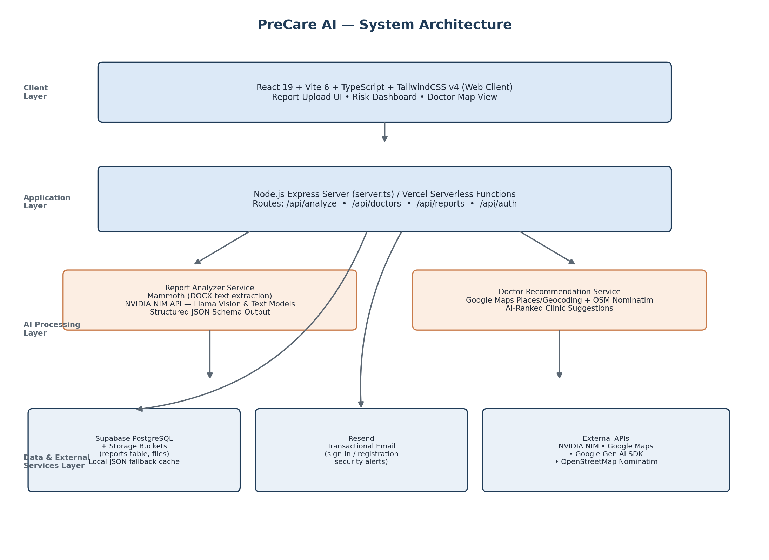
Figure 12.1 — PreCare AI layered system architecture

11. Data Flow Diagram (DFD)

11.1 Level 0 — Context Diagram
The context diagram shows PreCare AI as a single process exchanging data with three external entities: the patient, diagnostic report sources, and gynecologists/maternity clinics, alongside the email notification service.
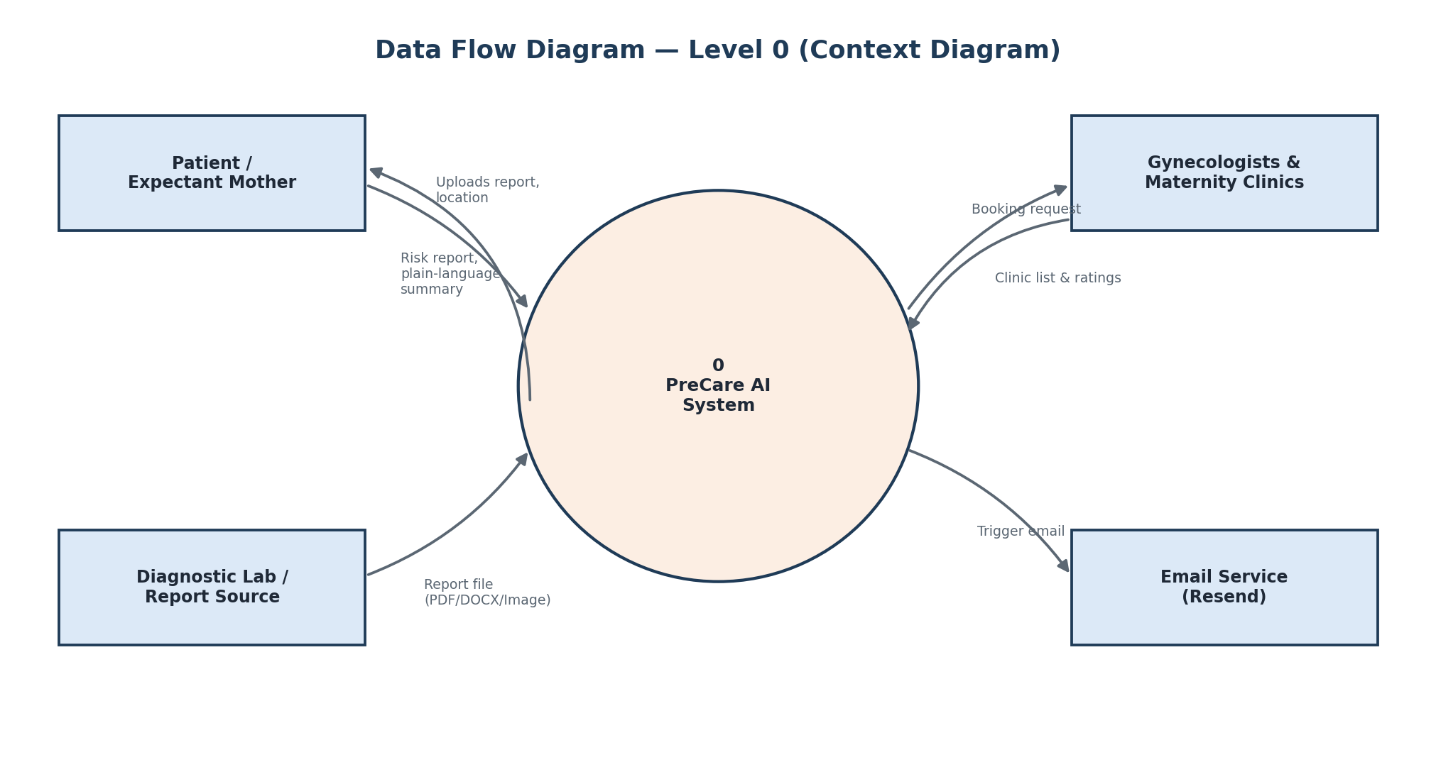
Figure 11.1 — Level 0 context diagram

11.2 Level 1 — Detailed Process Flow
The Level 1 diagram decomposes the system into nine core processes spanning report ingestion, AI analysis, risk classification, storage, and location-based clinic recommendation, supported by two data stores: the reports table and the file storage bucket.
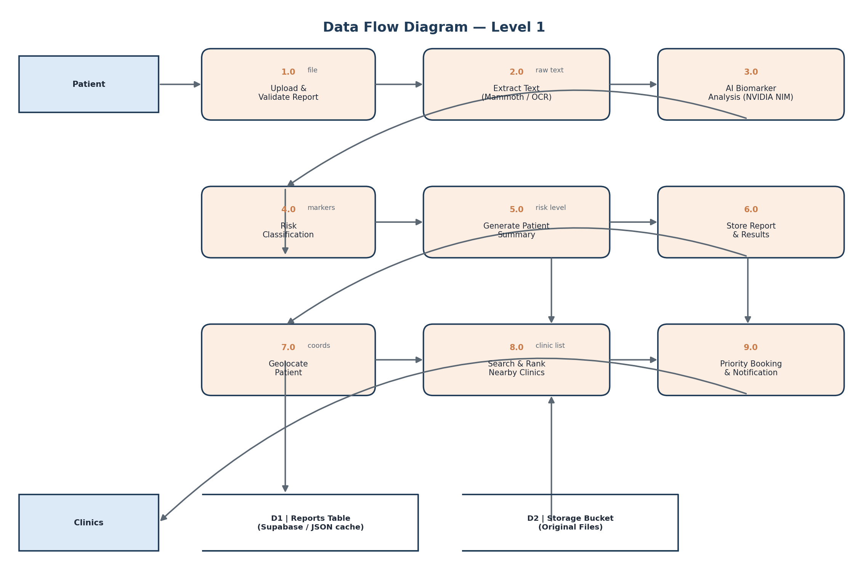
Figure 11.2 — Level 1 data flow diagram

12. User Interface Design
The interface is designed to minimize steps between report upload and actionable insight, using a clean, calming visual language appropriate for a maternal health context.
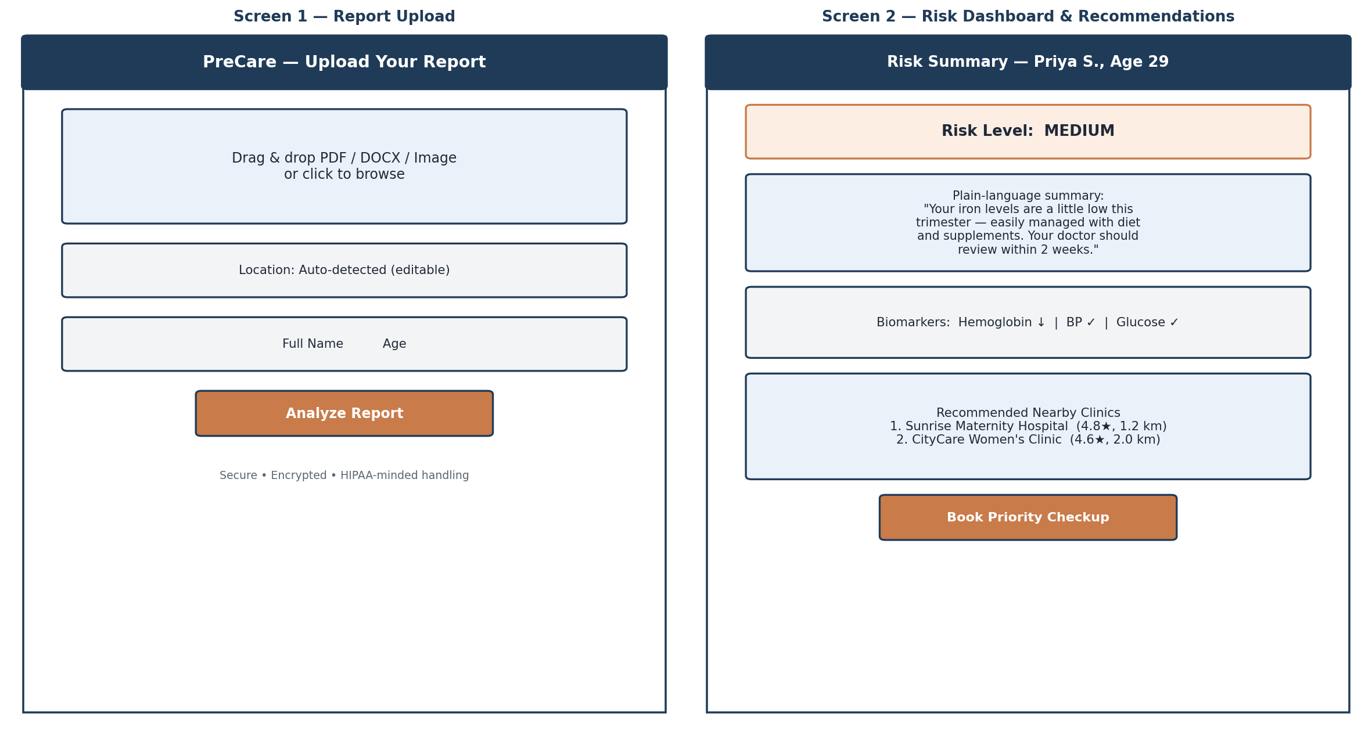
Figure 12.1 — Report upload screen and risk dashboard wireframes

12.1 Screen Descriptions
Screen | Purpose | Key Elements
Report Upload | Entry point for submitting a medical report | Drag-and-drop file zone, auto-detected location field, patient name/age input, Analyze button
Risk Dashboard | Displays AI-generated analysis results | Risk level badge, plain-language summary, biomarker status list, recommendations
Doctor Recommendations | Surfaces nearby, AI-ranked clinics | Clinic cards with rating/distance, personalized recommendation reason, priority booking button
Report History | Patient's stored records | List of past reports with date, risk level, and quick access to summaries

